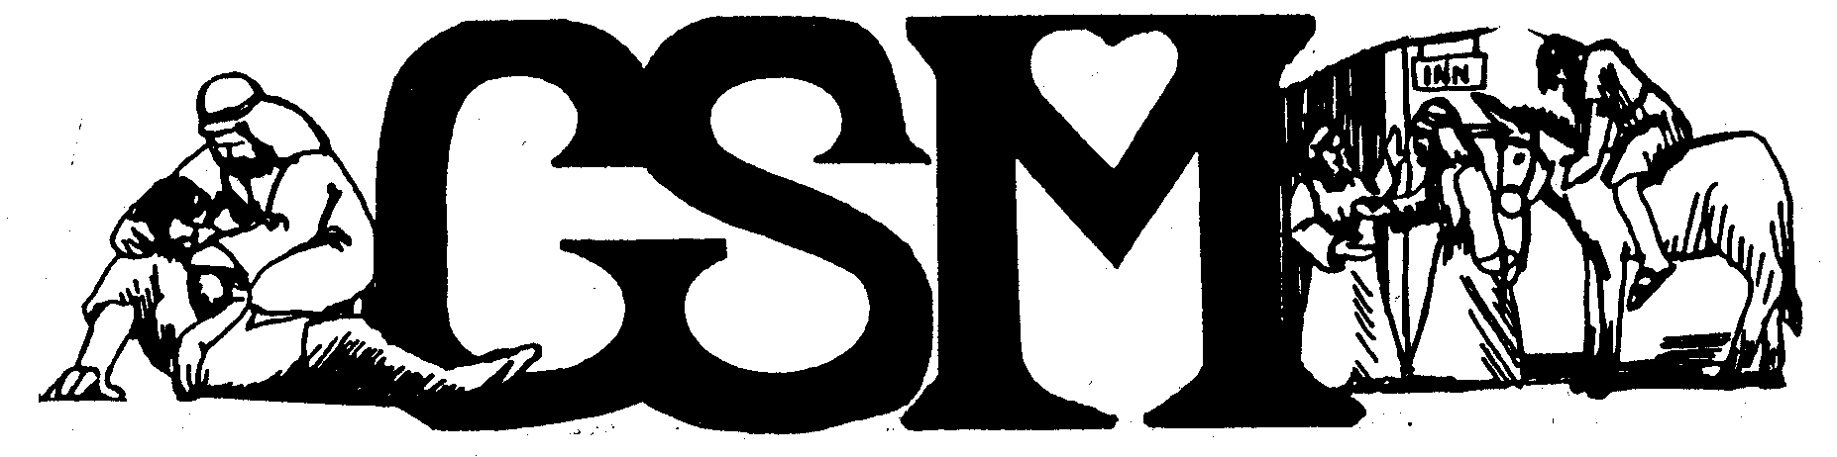 September | 2018
Office hours: 8:30 a.m.- 5:30p.m. Monday -Thursday or by appointment

Monday | Tuesday | Wednesday | Thursday | Friday | Saturday | Sunday
 |  |  |  |  | 1 | 2
3 | 4 | 5 | 6 | 7 | 8 | 9
Labor Day  Office Closed | Men’s Support Group  6:00-7:30 pm
10 | 11 | 12 | 13 | 14 | 15 | 16
General Support Grp  4:00-5:30 pm | Men’s Support Group  6:00-7:30 pm
17 | 18 | 19 | 20 | 21 | 22 | 23
General Support Grp  4:00-5:30 pm | Men’s Support Group  6:00-7:30 pm | Counselor Tr. Lev. 2/3  5:30 -8:00p.m. |  |  | GSM Pancake Feed  8:00-10:00 am
24  Personal Ministry Training 5:30-8:00pm | Men’s Support Group  6:00-7:30 pm | 26  Counselor Tr. Lev. 2/3  5:30 -8:00p.m. | 27 | 28 | 29 | 30
General Support Grp
4:00-5:30 pm
Events | GSM Nigerian Satellite Pancake Feed  Saturday Sept. 22, 2018-8:00-10:00am  Blue Mountain Community Church, 928 Sturm Ave, Walla Walla WA

